

Swinburne University of Technology
Lab04
REPORT
Applied Machine Learning - COS30082
Student Name: Truong Ngoc Gia Hieu
Student ID (VietNam): SWS01217
StudentID (Australia): 105565520
A. Data Loading and Exploratory Data Analysis 3
1.1 Data Loading 3
1.2 Exploratory Data Analysis 3
B. Data Preparation 6
2.1 Image Resizing and Normalization 6
2.2 Train-Validation Split 7
2.3 Dataset Summary and Samples 7
C. Convolutional Neural Network (CNN) Model 8
3.1 Base CNN Architecture 8
3.2 Training and Evaluation 13
3.3 Testing 14
D. Conclusion 15

Data Loading and Exploratory Data Analysis

Data Loading
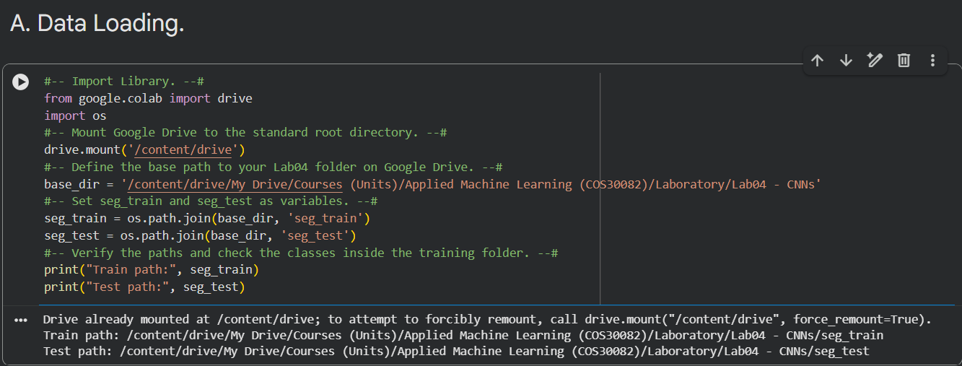
First and foremost, I had to download the dataset consisting of the seg_train and seg_test folders from the following Kaggle link: https://www.kaggle.com/datasets/puneet6060/intel-image-classification. Then, I uploaded them to Google Drive to easily import the data into Google Colab due to the large file size.
Figure 1: Google Drive Mounting & Path Configuration.

Exploratory Data Analysis
Next, in the Exploratory Data Analysis section, the number of images in the training and testing datasets was examined to analyze the class distribution and verify the total sample count for each category.
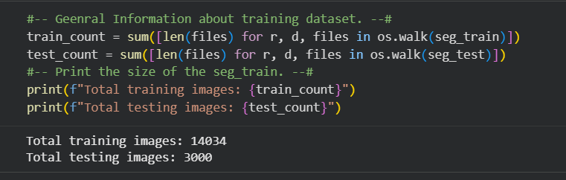
Figure 2: Dataset Training and Testing Size Overview.
Then, the following characteristics of each image were examined: resolution, color channels, file format, and file size.

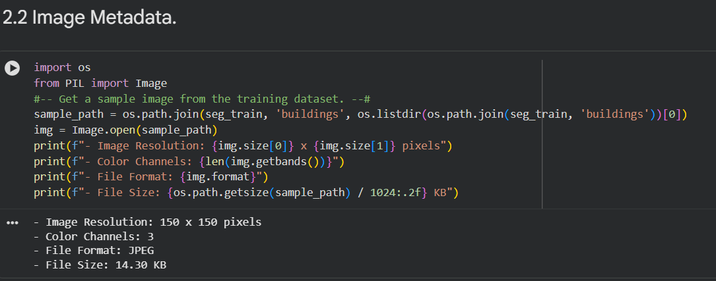
Figure 3: Image Metadata and Properties Overview.
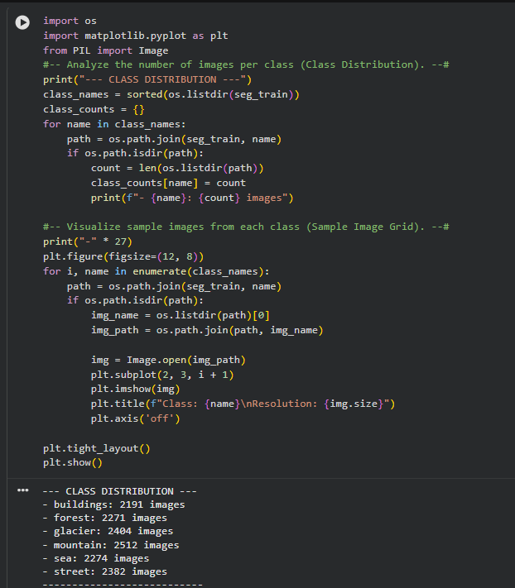
Figure 4: Training Class Distribution Analysis.

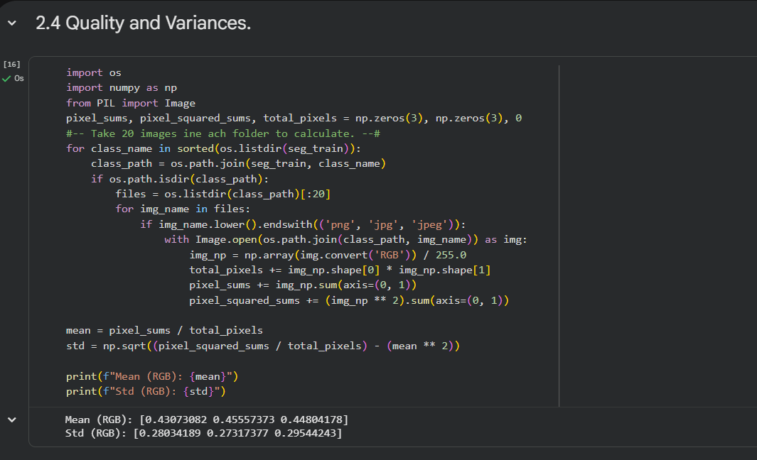
Figure 5: Pixel-Level Statistics and Normalization Parameters..
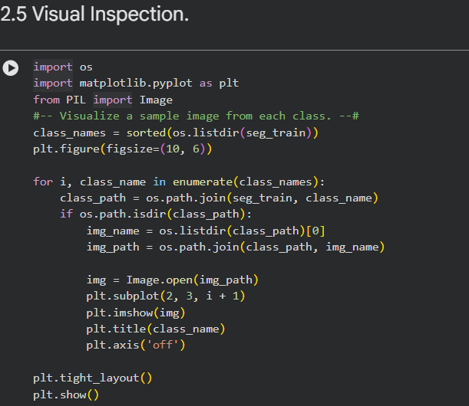
Figure 6: Sample Image Grid for Visual Inspection.

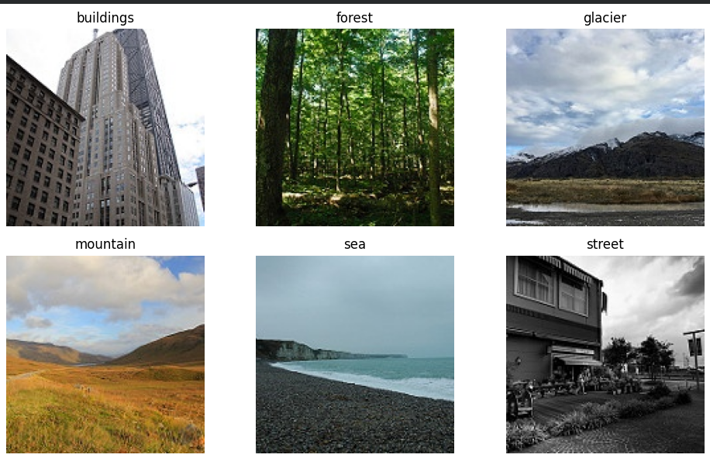
Figure 7: Sample Images Visualisation for Each Class.

Data Resizing and Normalization
In this section, the task requires students to load the dataset, resize images to 150x150 pixels, normalize pixel values to the range [0, 1], and split the training set into training and validation subsets.

2.1 Image Resizing and Normalization
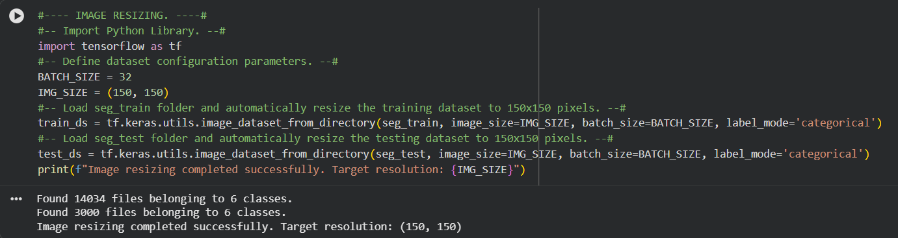
Figure 8: Dataset Loading and Resizing Output.
After resizing the image to 150x150, pixel normalization is applied to scale raw pixel values from the [0, 255] range down to [0, 1]. Notably, this crucial preprocessing step stabilizes gradient updates and significantly accelerates model convergence during training.

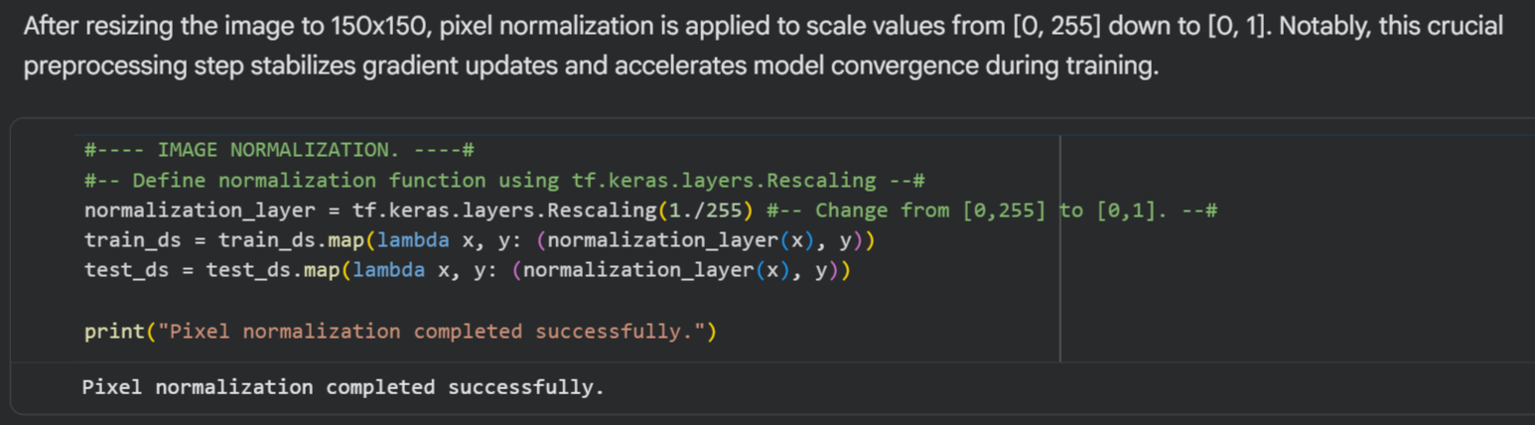
Figure 9: Image Pixel Normalization Code and Execution Output.

2.2 Train-Validation Split
Subsequently, the training dataset is partitioned into training and validation subsets. A 20% validation split (val_ds) is created to monitor model performance after each epoch, ensuring early detection and prevention of overfitting.
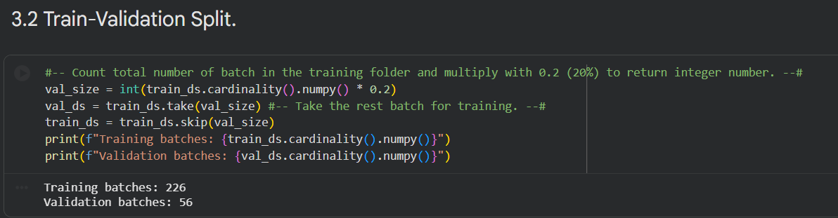
Figure 10: Train-Validation Split Code and Batch Output.

2.3 Dataset Summary and Sample
In this part, the given dataset comprises natural and urban scenes categorized into six distinct classes: buildings, forest, glacier, mountain, sea, and street. In terms of visual inspection of the data structure, a grid of sample images alongside their corresponding labels is plotted below, confirming successful data loading from the directory.
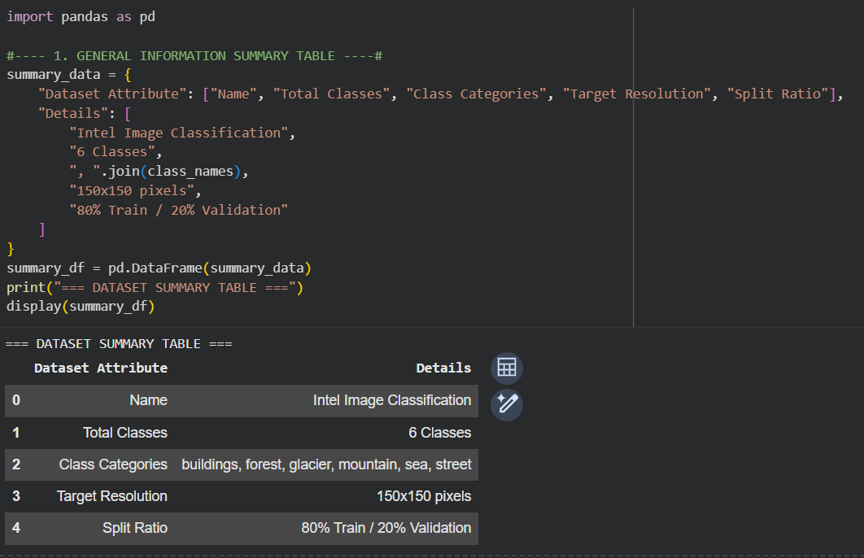

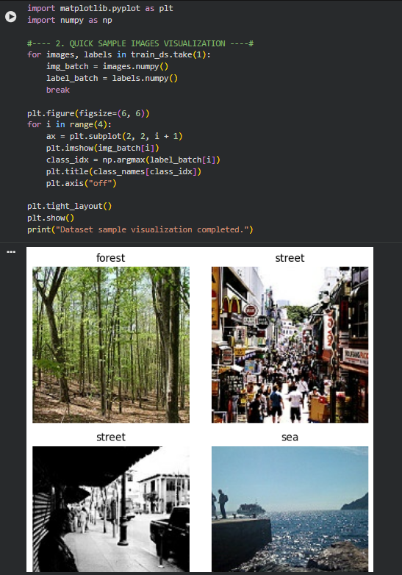
Figure 11: Summary Table of Dataset Attributes and Configuration.
Figure 12: Sample Dataset Images.

Convolutional Neural Network (CNN) Model

3.1 Base CNN Architecture
In the thirs section of the report, a baseline Convolutional Neural Network (CNN) architecture is implemented to establish a benchmark for image classification. Furthermore, the model extracts spatial features through sequential convolutional and pooling layers before classification. The model implementation and structural layout are presented below.
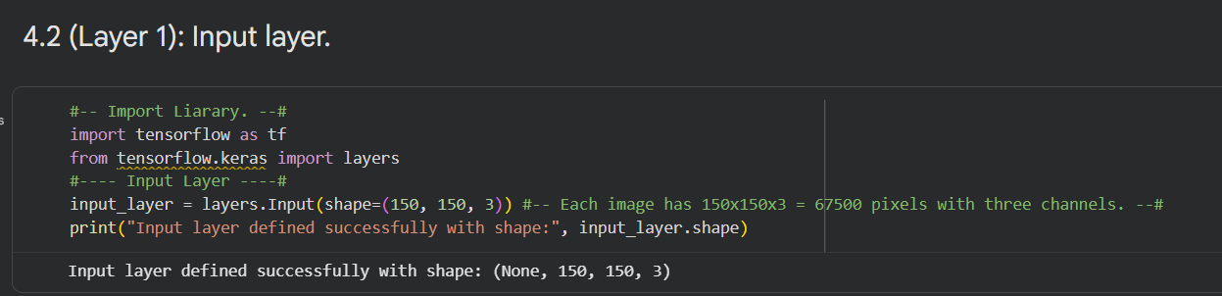
Figure 13: Input Layer.
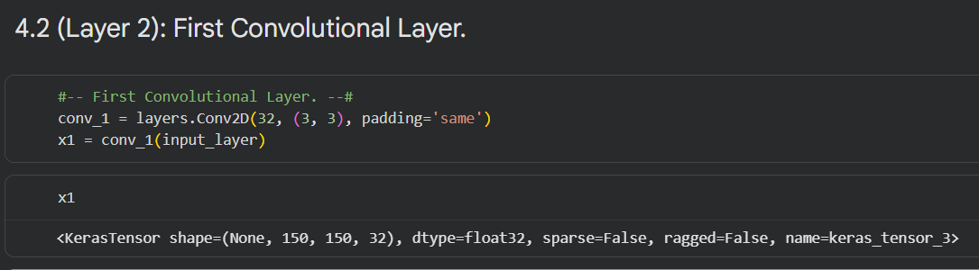
Figure 14: First Convolutional Layer.
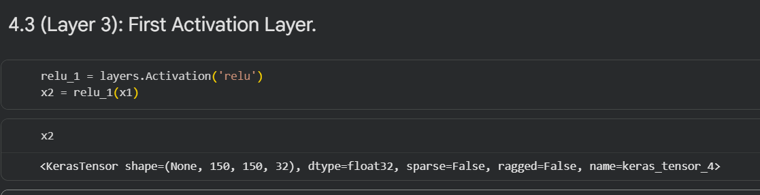
Figure 15: First Activation Layer.
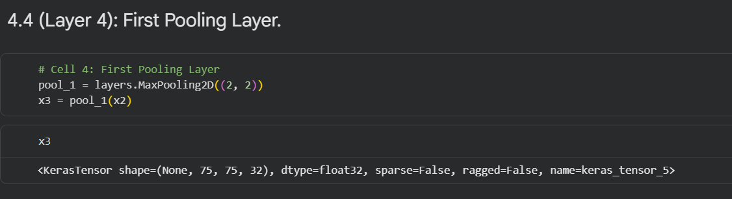
Figure 16: First Pooling Layer.
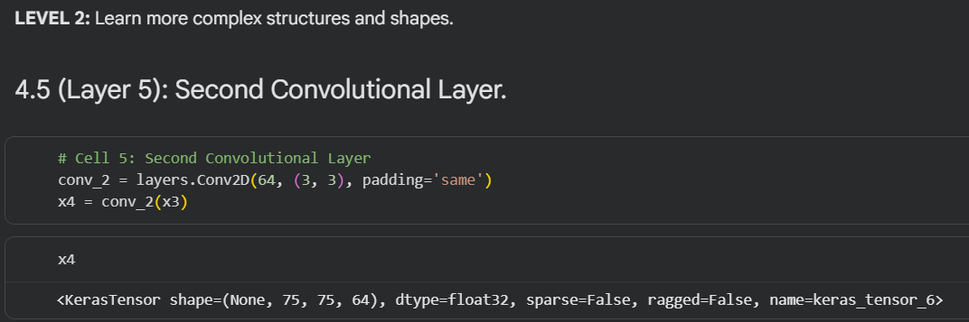
Figure 17: Second Convolutional Layer.

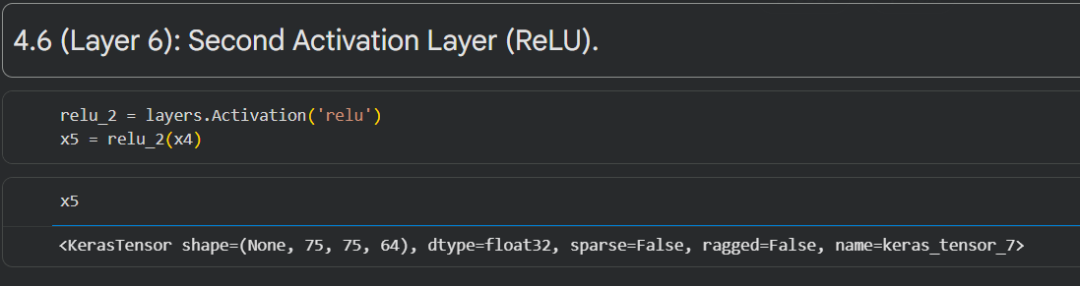
Figure 18: Second Activation Layer.
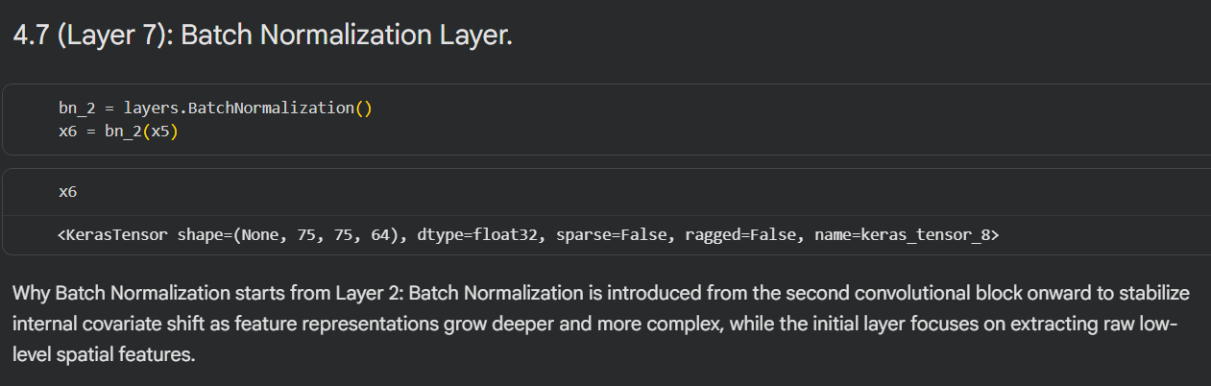
Figure 18: Batch Normolization Layer.
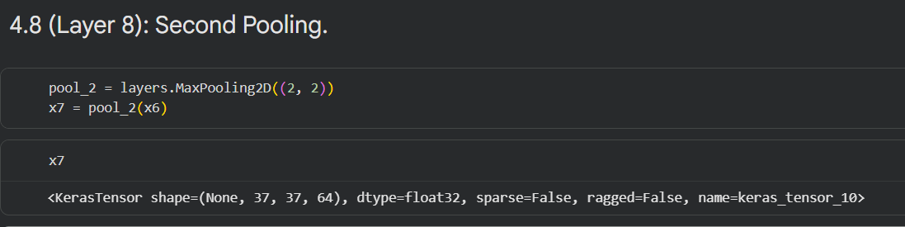
Figure 19: Second Pooling Layer.
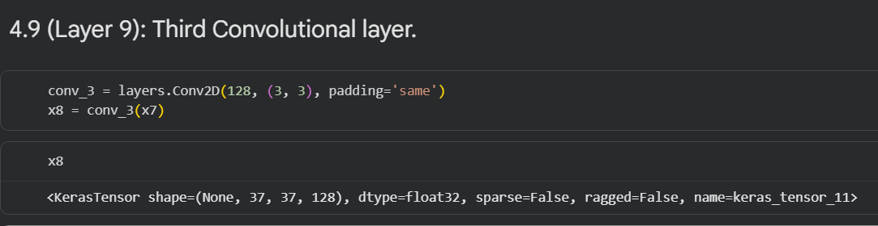
Figure 20: Third Convolutional Layer.
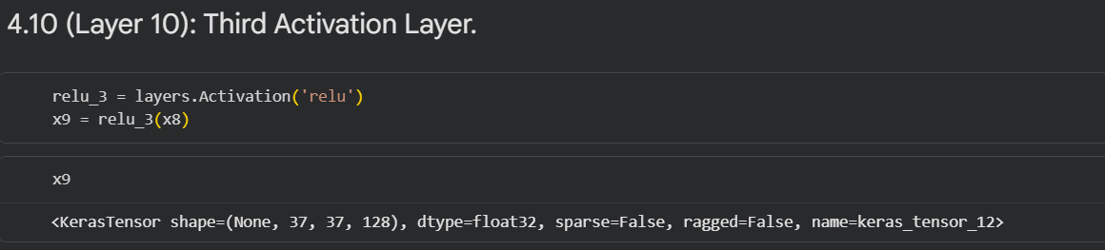
Figure 21: Third Activation Layer.

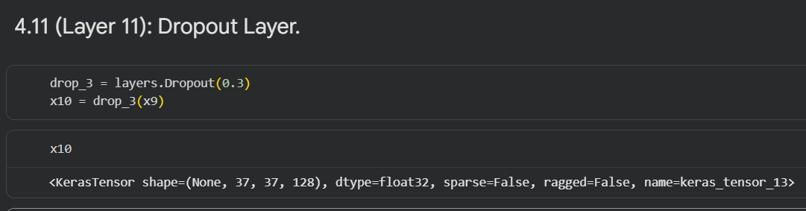
Figure 22: Dropout Layer.
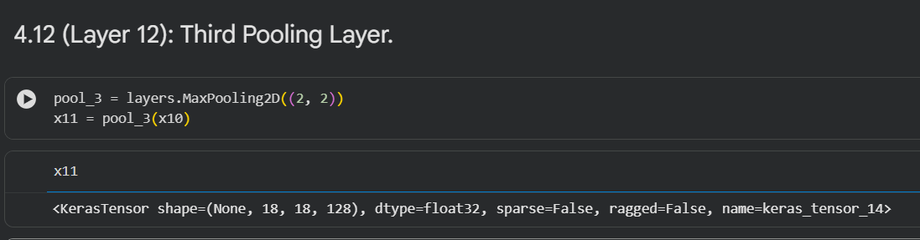
Figure 23: Third Pooling Layer.
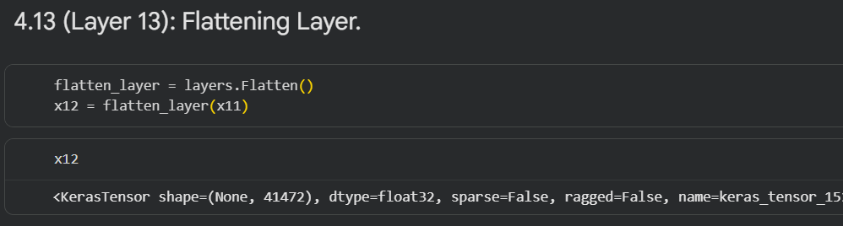
Figure 24: Flattening Layer.
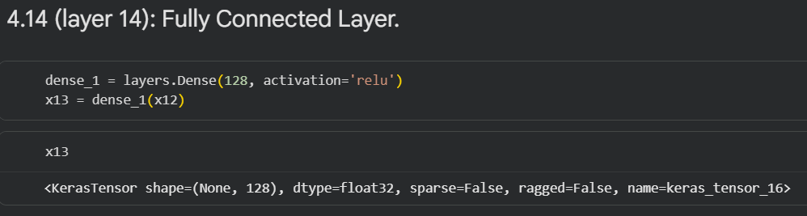
Figure 25: Fully Connected Layer.
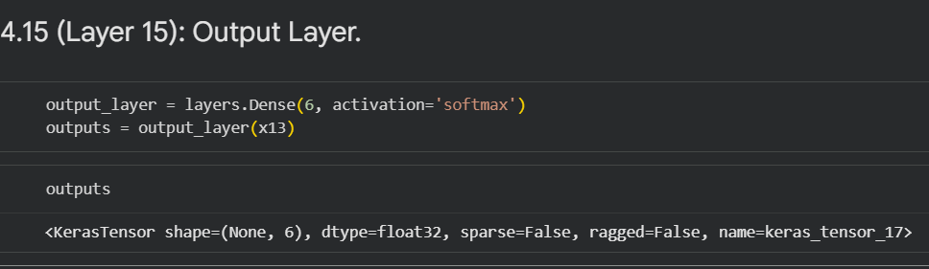
Figure 26: Output Layer.

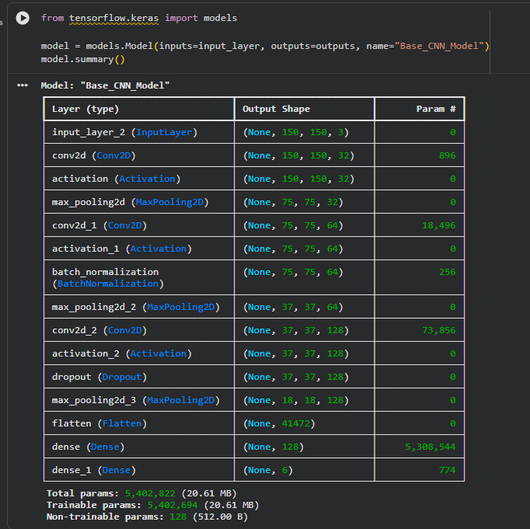
Figure 27: Assemble Final Model and Print Summary
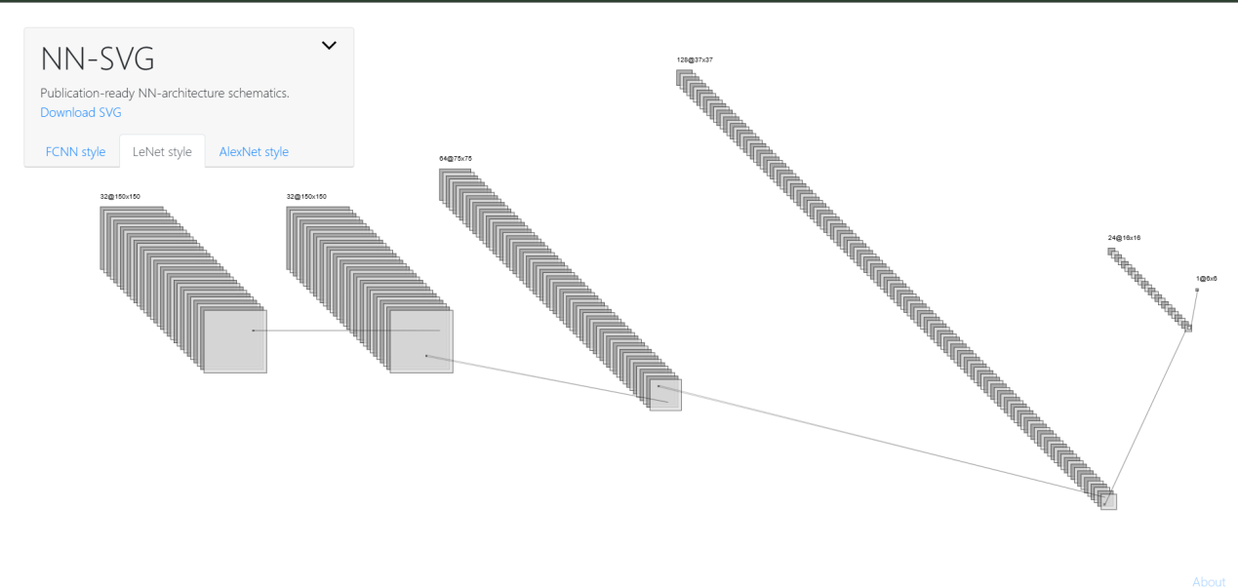
Figure 28: 3-Block CNN Architecture for Image Classification.

3.2 Training and Evaluation
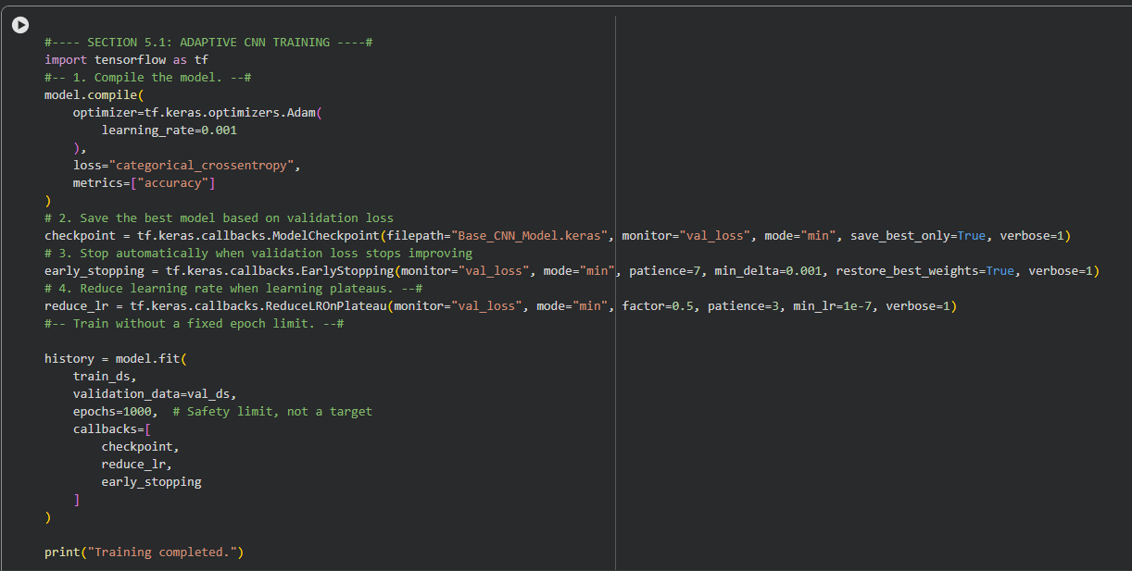
Figure 29: Training Model
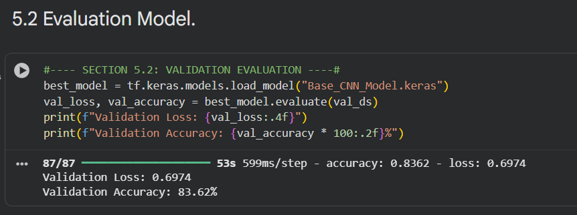
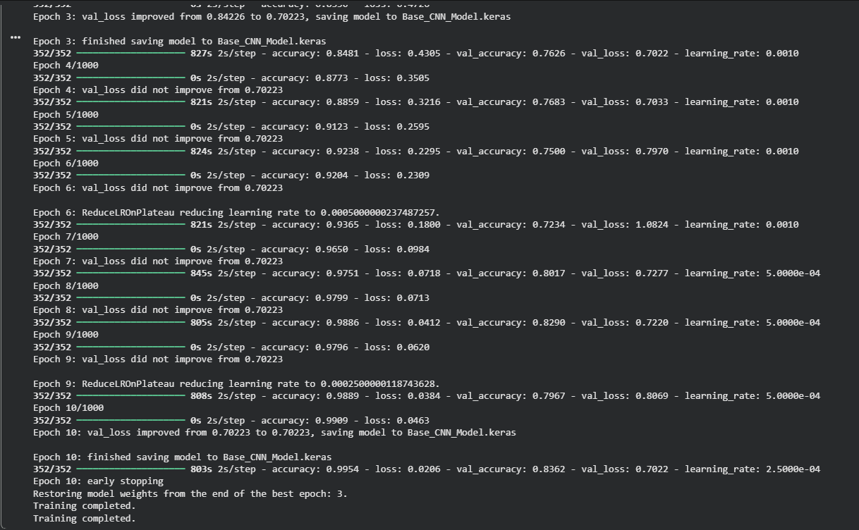
Figure 30: Training Log
Figure 31: Model Evaluation
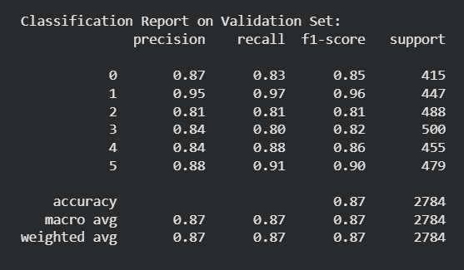
Figure 32: Classification Report on Validation Set

3.3 Testing
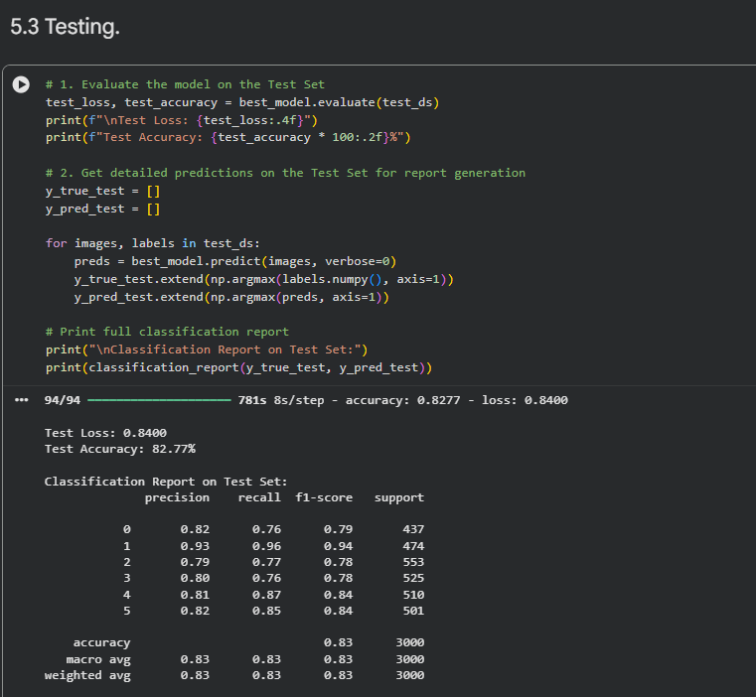
Figure 33: Baseline CNN Model Evaluation Output and Classification Report on the Test Dataset.

Conclusion
In this lab, a Baseline Convolutional Neural Network (CNN) model was successfully constructed, trained, and evaluated on the Intel Image Classification dataset. Specifically, the baseline architecture achieved a validation accuracy of 83.62% (Validation Loss: 0.6974). Furthermore, it generalized effectively to the unseen test dataset, securing an accuracy of 82.77% with a Test Loss of 0.8400. Although the model demonstrates robust image feature extraction and overall strong classification performance, the results nevertheless indicate clear potential for further optimization. Consequently, incorporating advanced regularization and data augmentation techniques in future iterations will be essential to mitigate overfitting and improve generalization on more complex visual patterns.

